**ACROPOLIS INSTITUTE OF TECHNOLOGY AND**

**RESEARCH**

**Department of Information Technology**

Synopsis

On

# Predictive Modelling Using Historical Sales Data To

# Forecast Future Product Demands

# 

1. **INTRODUCTION:** 
   1. **Overview:**

* In today’s competitive market, effective inventory management is crucial for businesses to meet customer demands while minimizing costs. This project focuses on utilizing **historical sales data** to forecast future product demands, reducing the risk of **stockouts** and **overstocking**.
* By analyzing **past sales trends, seasonal variations, and consumer behavior**, businesses can make **data-driven** inventory decisions. Poor inventory management leads to **lost sales, high storage costs, and inefficient supply chains**, making demand forecasting a critical requirement.
* This project explores various forecasting techniques to optimize inventory levels, contributing to improved **supply chain efficiency** and **customer satisfaction**.
  1. **Purpose of the project/Innovativeness and usefulness:**
* **Reduce Stockouts & Overstocking:** By accurately forecasting demand, businesses can prevent financial losses due to excess stock or unmet orders.
* **Improve Decision-Making:** The project provides a **data-driven** approach to managing inventory.
* **Enhance Operational Efficiency:** Reducing waste and optimizing storage will improve supply chain efficiency.
* **Increase Profitability:** By maintaining optimal inventory levels, businesses can reduce unnecessary costs and maximize revenue.
* **Minimize Waste:** Reduce excess inventory and prevent spoilage or obsolescence, especially for perishable or time-sensitive products.
* **Enhance Customer Satisfaction:** Ensure products are always available when customers need them, reducing the risk of lost sales due to stockouts.
* **Facilitate Product Diversification:** Allow businesses to manage a wider range of products efficiently, supporting diversification strategies
* **Support Market Expansion:** Enable businesses to enter new markets or regions by providing scalable and adaptable inventory management solutions.

1. **LITERATURE SURVEY:** 
   1. **Existing Problem:**

* **Inefficient Forecasting:** Traditional inventory management lacks predictive analytics, leading to stockouts or excessive inventory.
* **Seasonal Demand Variability:** Many companies fail to anticipate seasonal trends, leading to inventory mismanagement.
* **Manual Processes:** Relying on manual inventory tracking is prone to errors and inefficiencies.
* **High Storage Costs:** Overstocking results in increased holding costs, while understocking leads to lost sales.
* **Supply Chain Disruptions:** External factors like supplier delays, logistical failures, and unexpected demand spikes make it difficult to maintain steady inventory levels.
* **Manual & Error-Prone Inventory Management:** sses still use manual processes like spreadsheets and physical stock counts, leading to: Data Entry Mistakes, Time-Consuming Operations, Lack of Automation
  1. **Proposed Solution:**
* **Real-Time Visibility and Reporting**

Mobile Accessibility: Provide mobile-friendly dashboards and apps for on-the-go inventory management and decision-making.

Customizable Alerts: Configure automated alerts for low stock levels, expiring items, or unusual activity in the supply chain.

Performance Analytics: Generate detailed reports on key metrics like inventory turnover, carrying costs, and stockout rates to identify areas for improvement.

* **Centralized and Scalable Systems**

Cloud-Based Platform: Implement a cloud-based inventory management system for centralized data storage, scalability, and remote access.

Integration with ERP and CRM Systems: Ensure seamless data flow between inventory management, enterprise resource planning (ERP), and customer relationship management (CRM) systems.

Multi-Channel Inventory Management: Synchronize inventory across online and offline sales channels to prevent overselling and improve customer satisfaction.

* **Training and Change Management**

Employee Training: Provide training programs to help staff adapt to new technologies and processes.

Change Management Strategies: Develop strategies to ensure smooth adoption of new systems and minimize resistance to change.

1. **THEORITICAL ANALYSIS**
   1. **Block Diagram:**

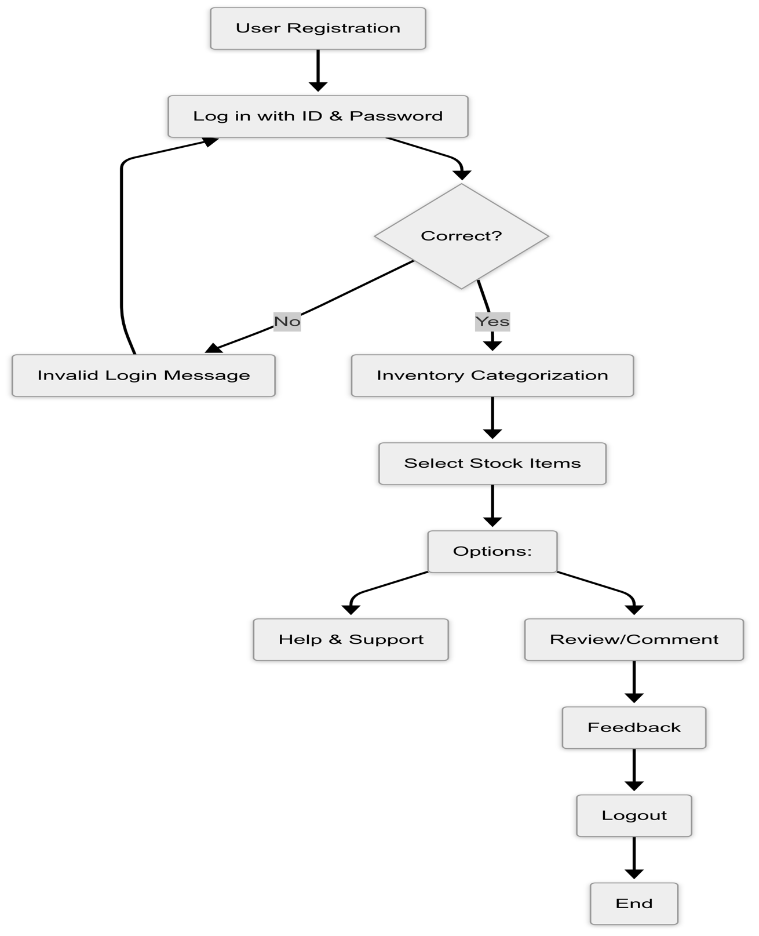

Fig.1 Block Diagram of Smart Inventory Management.

* 1. **Required Resources:** 
     + **Hardware Requirements:**

1. **Server / Cloud Hosting** – To store and process inventory data.
2. **Storage Devices** – Hard drives or cloud databases for historical sales data.
3. **Computing Devices** – Computers or mobile devices to access inventory reports.

* **Software Requirements:**

1. **Programming Languages:** Python, R
2. **Forecasting Tools:** Statsmodels, Prophet, Scikit-learn
3. **Database Management:** MySQL, NoSQL (MongoDB)
4. **Visualization Tools:** Tableau, Power BI
5. **Machine Learning Frameworks:** TensorFlow, Scikit-learn

**4. APPLICATION:**

1. Retail Industry: Enhancing inventory management and customer satisfaction by ensuring product availability.
2. E-commerce: Optimizing stock levels based on predictive analytics to improve order fulfillment rates.
3. Manufacturing: Streamlining production schedules and raw material procurement based on demand forecasts.
4. Supply Chain Management: Improving overall efficiency by aligning inventory levels with predicted sales.
5. Seasonal Products: Assisting businesses in preparing for peak seasons by accurately forecasting demand.
6. Pharmaceutical Industry: Managing medicine stocks is critical due to expiration dates and regulatory requirements.
7. Food & Beverage Industry: Perishable goods require accurate inventory tracking to reduce spoilage and optimize delivery schedules. This system supports:
8. Automotive & Spare Parts Industry: Managing spare parts inventory is challenging due to varying demand for different components.
9. Fashion & Apparel Industry: The fashion industry experiences fast-changing trends and seasonal demand shifts.
10. Aviation & Aerospace Industry: Airlines and aerospace manufacturers need critical component tracking to maintain safety and compliance standards.

**5. REFERENCES:**

1. [**https://www.researchgate.net/publication/383560175_AI-driven_demand_forecasting_Enhancing_inventory_management_nd_customer_satisfaction**](https://www.researchgate.net/publication/383560175_AI-driven_demand_forecasting_Enhancing_inventory_management_nd_customer_satisfaction)
2. [**https://disk.com/resources/inventory-forecasting-methods-to-reduce-stockouts-overstock/#:~:text=Seasonality%20Analysis,-Retailers%20often%20face&text=This%20method%20relies%20on%20historical,by%20managing%20their%20inventory%20carefully**](https://disk.com/resources/inventory-forecasting-methods-to-reduce-%20stockouts-overstock/#:~:text=Seasonality%20Analysis,- Retailers%20often%20face&text=This%20method%20relies%20on% 20historical,by%20managing%20their%20inventory%20carefully)
3. [**https://www.pecan.ai/blog/predictive-inventory-management/**](https://www.pecan.ai/blog/predictive-inventory-management/)
4. [**https://thousense.ai/blog/accurate-demand-forecasting-for-effective-inventory-management/**](https://thousense.ai/blog/accurate-demand-forecasting-for-effective-inventory-management/)
5. [**https://codup.co/blog/how-to-avoid-overstocking-and-stockouts-in-retail-best-practices-for-inventory-planning/**](https://codup.co/blog/how-to-avoid-overstocking-and-stockouts-in-retail-best-practices-for-inventory-planning/)
6. [**https://www.netstock.com/blog/demand-forecasting-for-supply-chains-how-to-predict-plan/**](https://www.netstock.com/blog/demand-forecasting-for-supply-chains-how-to-predict-plan/)
7. **https://ijrpr.com/uploads/V5ISSUE10/IJRPR34021.pdf**

**Guided By: Group Members:**

Prof. Mahendra Verma Khushi Agrawal (0827IT221076)

Atharv Sharma (0827IT233D02)

Akshat Soni (0827IT221011)

Amay Saxena (0827IT221014)